Saturday Sept 12, 2026
Time: 10 o’clock until 4pm
Location: 1000 Bethune Dr. Orlando, Florida
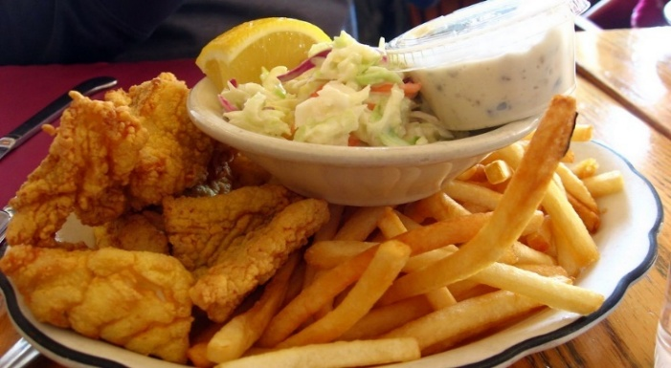

Fish Sandwich $7
Fish and Grits or Fish and Fries $10
Contact
Lora F.
407-288-7335
Drinks also for sell
Meeting at 1pm
www.orlandona.org
Greater Orlando Area Helpline
407-425-5157 and 866-579-8333
Relay Number for Deaf 1-800-955-8771 or 711
*NA is not affiliated with this facility


